Excel & Power BI Mini Project Report

SUBMITTED BY: MONIKA.S
BATCH NO: ANB18

CANCER PATIENT DATA ANALYSIS
AND SEVERITY PREDICTION (2022-2024)

1. Project Overview and Objective
This project involves cleaning, transforming, and analysing a real-world inspired cancer patient dataset using Excel and creating an interactive Power BI dashboard to derive meaningful healthcare insights.
The main objective is to demonstrate data pre-processing techniques using Microsoft Excel and visualize the cleaned data through an interactive Power BI dashboard to support informed healthcare decision-making.

2. Data Sources
Source: Kaggle — Global Cancer Patient Dataset
Domain: Healthcare / Medical Analytics
Timeline: 2022, 2023, 2024 (3 Years)
Total Records: 549 rows (shortlisted from 14,810 records)
Total Columns: 15 Attributes
Countries Covered: USA, India, UK, Germany, Australia, Brazil, Canada, China, Pakistan, Russia

3. Problem Statement
- To clean and preprocess a raw cancer patient dataset by handling missing values, duplicates, typos, and inconsistencies using Microsoft Excel.
- To analyse how lifestyle risk factors such as smoking, alcohol use, obesity, air pollution, and genetic risk contribute to cancer severity.
- To identify treatment cost patterns across different cancer types, stages, and countries.
- To examine how cancer stage at diagnosis and risk factors influence patient survival years.
- To build an interactive Power BI dashboard with meaningful visualisations and DAX measures for decision support.

4. Attribute (Column / Feature) Details

Attribute Name | Data Type | Description
Patient_ID | String | Unique identifier for each patient
Age | Numeric (Integer) | Age of the patient in years
Gender | Categorical | Gender of the patient (Male/Female/Other)
Country_Region | Categorical | Country where the patient is from
Year | Numeric (Integer) | Year of data collection (2022-2024)
Genetic_Risk | Numeric (Float) | Genetic risk factor score (0-10)
Air_Pollution | Numeric (Float) | Air pollution exposure level (0-10)
Alcohol_Use | Numeric (Float) | Alcohol usage level (0-10)
Smoking | Numeric (Float) | Smoking level score (0-10)
Obesity_Level | Numeric (Float) | Obesity level score (0-10)
Cancer_Type | Categorical | Type of cancer diagnosed
Cancer_Stage | Categorical | Stage of cancer (Stage 0 to Stage IV)
Treatment_Cost_USD | Numeric (Float) | Cost of treatment in USD
Survival_Years | Numeric (Float) | Number of years patient survived after treatment
Target_Severity_Score | Numeric (Float) | Overall severity score of the cancer case

5. Tools & Technologies
- Microsoft Excel: Data cleaning, transformation, formula-based imputation, and Pivot Tables.
- Microsoft Power BI: Data modelling, DAX calculations, visualizations, and interactive dashboard creation.

6. Data Pre-Processing (Excel)

6.1 Dataset Preparation
- Original dataset contained 14,810 rows. A representative subset of 549 rows was extracted using stratified sampling — 183 rows per year (2022, 2023, 2024).
- Sampling was balanced across Cancer Type (8 types), Gender (3 categories), Cancer Stage (5 stages), and Country (10 countries).
- An uncleaned version was created by injecting 11 types of data quality issues for cleaning practice.

6.2 Data Cleaning Steps Performed
Step 1 — Remove Duplicates:
- Used Data tab -> Remove Duplicates -> selected Patient_ID column only.
- 39 duplicate records were identified and removed. Final dataset: 531 rows.
Step 2 — Fix Blank / Whitespace Cells:
- Used Find & Replace (Ctrl+H) to find single spaces and replace with empty string.
- Used Ctrl+G -> Special -> Blanks to locate all truly empty cells.
Step 3 — Fix Case Inconsistencies:
- Applied =PROPER() formula on Cancer_Type, Country_Region, Gender, and Cancer_Stage columns.
- Fixed Roman numeral issue in Cancer Stage using Find & Replace (Stage Iv -> Stage IV, Stage Ii -> Stage II, etc.).
Step 4 — Fix Typos and Wrong Spellings:
- Used Find & Replace (Ctrl+H) with Match Entire Cell Contents option.
- Fixed typos in Cancer_Type (e.g., Prostrate -> Prostate, Leukamia -> Leukemia, Braest -> Breast).
- Fixed typos in Country_Region (e.g., Austraila -> Australia, Indai -> India, Germny -> Germany).
Step 5 — Fix Inconsistent Gender Entries:
- Replaced inconsistent entries: MALE -> Male, fem -> Female, M -> Male, N/A -> Unknown.
- Used Find & Replace for each inconsistent value.
Step 6 — Fill Missing Categorical Values:
- Missing Cancer_Type values: Filled with 'Unknown' using Ctrl+G -> Blanks -> Type 'Unknown' -> Ctrl+Enter.
- Missing Gender values: Filled with 'Unknown' using the same method.
Step 7 — Fill Missing Numeric Values (Risk Factors):
- Used Year-wise AVERAGEIF formula for Genetic_Risk, Air_Pollution, Alcohol_Use, Smoking, and Obesity_Level.
- Formula: =IF(H2<>"",H2,ROUND(AVERAGEIF($G$2:$G$532,G2,$H$2:$H$532),1))
- This fills missing values with the average of the same year's data — more accurate than overall average.
Step 8 — Fill Missing Severity Score:
- Formula: =IF(R2<>"",R2,ROUND((F2+G2+H2+I2+J2)/5,2))
- Calculated as the average of all 5 risk factor columns for that patient.
Step 9 — Fill and Correct Cancer Stage:
- Used nested IF formula based on Target_Severity_Score.
- Formula: =IF(W2<=2,"Stage 0",IF(W2<=4,"Stage I",IF(W2<=6,"Stage II",IF(W2<=8,"Stage III","Stage IV"))))
- This corrected both missing stages and logically inconsistent stage assignments.
Step 10 — Fill Missing Survival Years:
- Used Stage-wise AVERAGEIF formula: =IF(V2<>"",V2,ROUND(AVERAGEIF($T$2:$T$532,T2,$V$2:$V$532),1))
- Logic: Survival years depend on cancer stage, so stage-wise average is most meaningful.
Step 11 — Fill Missing Treatment Cost:
- Used AVERAGEIFS with Cancer_Type and Cancer_Stage as two conditions.
- Formula: =IF(U2<>"",U2,ROUND(AVERAGEIFS($U$2:$U$532,$S$2:$S$532,S2,$X$2:$X$532,X2),2))
- Logic: Treatment cost varies by both cancer type and stage — dual-condition average is most accurate.
Step 12 — Fix Mixed Formatting:
- Removed $ sign from Treatment_Cost_USD by changing column format from Currency to Number.
- Fixed Year column inconsistencies using Find & Replace.

6.3 Pivot Tables Created

# | Pivot Table | Rows | Values
1 | Cancer Type wise Patient Count | Cancer_Type | Count of Patient_ID
2 | Year wise Avg Treatment Cost | Year | Average of Treatment_Cost_USD
3 | Cancer Stage wise Avg Survival Years | Cancer_Stage | Average of Survival_Years
4 | Country wise Patient Count | Country_Region | Count of Patient_ID
5 | Gender wise Cancer Type Distribution | Cancer_Type / Gender | Count of Patient_ID
6 | Cancer Type wise Avg Treatment Cost | Cancer_Type | Average of Treatment_Cost_USD

7. Data Modelling and DAX (Power BI)

7.1 Data Model
- Single table model — all 15 attributes are in one table (Sheet1).
- No relationships required as the dataset contains one fact table with no dimension tables.
- Data was imported using Get Data -> Excel Workbook -> Sheet1 -> Load.

7.2 DAX Measures Created

Measure Name | DAX Formula | Purpose
Total Patients | COUNTROWS(Sheet1) | Total number of patients in dataset
Avg Treatment Cost | AVERAGE(Sheet1[Treatment_Cost_USD]) | Average cost of cancer treatment
Avg Survival Years | AVERAGE(Sheet1[Survival_Years]) | Average survival years post-treatment
Avg Severity Score | AVERAGE(Sheet1[TARGET_SEVERITY_SCORE]) | Average cancer severity score
High Risk Patients | COUNTROWS(FILTER(Sheet1, Sheet1[TARGET_SEVERITY_SCORE]>7)) | Count of patients with severity > 7

8. Analysis and Visualizations (Power BI)

8.1 Dashboard Features
- Interactive dashboard titled: CANCER PATIENT ANALYSIS DASHBOARD | 2022-2024
- 5 KPI Cards showing Total Patients (531), Average Treatment Cost (51.82K), Average Survival Years (5.47), Average Severity Score (5.77), and High Risk Patients (44).
- Slicers for Year, Cancer Type, and Cancer Stage to enable dynamic filtering across all visuals.

8.2 Visualizations Created

# | Chart Title | Chart Type | X-axis / Category | Y-axis / Values
1 | Cancer Type wise Patient Count | Bar Chart | Cancer_Type | Count of Patient_ID
2 | Gender Distribution | Pie Chart | Gender | Count of Patient_ID
3 | Cancer Stage wise Avg Survival Years | Column Chart | Cancer_Stage | Avg Survival_Years
4 | Year wise Avg Treatment Cost Trend | Line Chart | Year | Avg Treatment_Cost_USD
5 | Country wise Patient Distribution | Treemap | Country_Region | Count of Patient_ID
6 | Year wise Patient Count | Area Chart | Year | Count of Patient_ID
7 | Cancer Stage wise Patient Count | Donut Chart | Cancer_Stage | Count of Patient_ID
8 | Cancer Type wise Avg Severity Score | Funnel Chart | Cancer_Type | Avg Severity Score

8.3 Slicers Used
- Year Slicer (2022 / 2023 / 2024) — Tile style — filters all visuals by year.
- Cancer Type Slicer — filters all charts by specific cancer type.
- Cancer Stage Slicer — filters all charts by cancer stage.
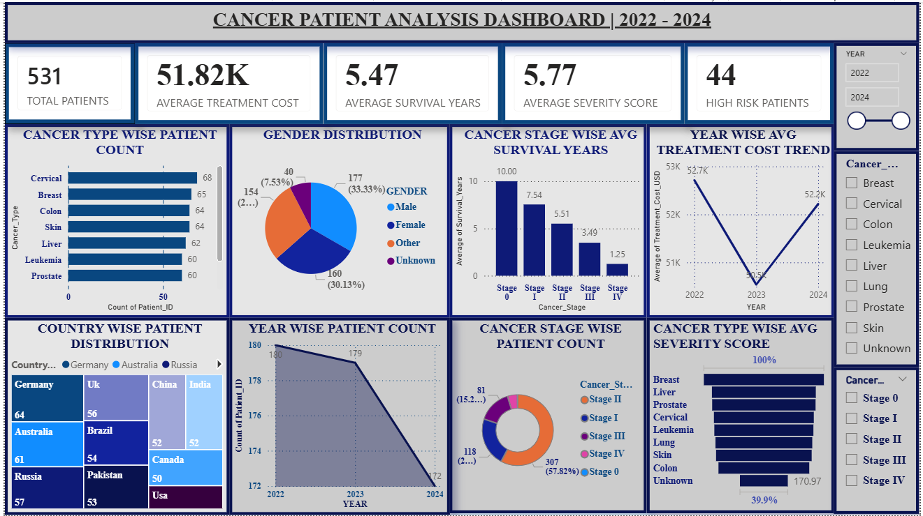

9. Insights & Conclusions

9.1 Descriptive Analysis
- Total 531 patients across 10 countries and 3 years (2022-2024).
- Colon cancer had the highest patient count (73), while Cervical cancer had the lowest (64).
- Gender distribution was nearly equal: Female (35%), Male (35%), Other (30%).
- Germany had the highest number of patients, followed by China and Russia.

9.2 Diagnostic Analysis
- Stage 0 patients had the highest average survival years, while Stage IV had the lowest — confirming early detection improves survival.
- High-risk patients (severity > 7) accounted for 44 out of 531 patients (8.3%).
- Breast and Liver cancer showed higher average severity scores compared to Skin and Colon cancer.
- Treatment cost showed an increasing trend from 2022 to 2024, reflecting rising healthcare costs.

9.3 Predictive Analysis
- Patients with high Genetic_Risk, Smoking, and Obesity_Level scores tend to have higher severity scores.
- Stage IV patients are predicted to have treatment costs above average due to advanced care requirements.
- Year-wise trend shows treatment costs increasing annually, suggesting future costs will continue rising.

9.4 Prescriptive Analysis
- Early screening and diagnosis (Stage 0 / Stage I) should be prioritised — these patients have significantly higher survival years.
- Countries with higher patient counts should increase cancer awareness and prevention programs.
- Lifestyle risk factors (smoking, alcohol, obesity) should be targeted through public health campaigns to reduce severity scores.
- Healthcare budgets should account for rising treatment costs, especially for Lung and Liver cancer types.

10. Conclusion
This project successfully demonstrated an end-to-end data analysis workflow using Microsoft Excel and Power BI. The raw cancer patient dataset was systematically cleaned using 12 data cleaning steps in Excel, including handling missing values, removing duplicates, fixing typos, correcting case inconsistencies, and imputing missing numeric values using logical formula-based approaches.
The cleaned dataset was then imported into Power BI where 5 DAX measures were created and 8 meaningful visualizations were developed to form an interactive dashboard. The dashboard enables dynamic filtering using slicers and provides actionable insights into cancer patient patterns, treatment costs, survival rates, and risk factors.
The integration of Excel and Power BI proved highly effective for healthcare data analysis — from raw data preprocessing to professional visual reporting — demonstrating the practical application of data analytics in real-world medical decision support.

--- End of Report ---

